User Menu Improvement Design

DOC. No.: | REV.: 00 |  |  | PRODUCT:
TITLE: User Menu Improvement Design |  |  |  | Project:
Prepared by: | Ray |  |  | Date:
Remark: | Approval:
Remark: |  | Department | Title |  |  | Signature
Remark: | 1 | Electronic R&D
Remark: | 2
Remark: | 3
Remark: | 4

Revision | Description of Change | Author | Date
00 | Draft

1. Overview 4
1.1. Objective 4
1.2. Scope 4
1.3. Overview 4
1.4. Reference 4
1.5. Abbreviations 4
1.5.1. heading3 4
2. Before improvement 4
3. The improvement 4
3.1. Improvement objective 5
3.2. The improvement steps 5
Appendix 6

Overview

Objective
This document describes the consideration, method, steps of user menu improvement.

Scope
Before improvement the scope is the user menu of SL series;
After improvement the scope is the user menu of SL15 project.

Overview
The SL15 project introduces new human interface device to the vending machine, the original two colours LCD and key pad are substituted by a 4.3 inches 24 bits colour LCD with touch panel, the main board platform is changed to WINCE too, that cause a lot of changes on the user menu.

Reference

Abbreviations

Issues
controls methods
1. HIH façade control dialogs, the dialog do not contain application logic, the façade invoke refresh on dialog, and the dialog will call the façade function to get what data it want.
2. Dialogs contain part of application logic, include navigate to other screens

How to deal with operation timeout?

When and how to hih_handle_errors_warnings?

What is credit preference? handle_preference
The favour product can be saved and associated with the credit card?

How to implement HIH_MODE_STANDY and HIH_MODE_FUNCTIONAL_OFF?
What is the deduct screen?

How to show instant message(ID_CRH) and error message
Popup or show in dialog?

What happen when connect to multiple slave machines?

How to deal with multiple language support?

Character set, Unicode ?

Solved:
Either The façade know about the dialog? Push data to dialog object before show or refresh it?
For coupling to the UI layer doesn’t seem to be a good idea, design dialog as observer, update an element in screen may causing the screen refreshing, optimization may need.

Improvement objective
Port the user menu to WINCE, replacing the text mode interface with graphic interface.

Develop an attractive interface to enhance customer's experience.

Because UI applications are volatile, the user interface should flexible enough to adapt the changes. These are possible changes need to take care:
The process of an operation e.g. vending
The layout or content of a screen
The underline graphic library

The improvement

UI tasks
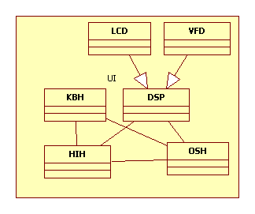
Before improvement the UI interface consists of several tasks, after improvement only HIH is left. OSH is combined to HIH, works as a special state of HIH. Messages sent to OSH before need to redirect to HIH.

To narrow the affected scope of this improvement, the communication messages among HIH and most of the tasks, CRH, VEH etc would keep unchanged,
Conversion may proceed before messages sent to these tasks.
Improving the codes related to HIH state machine are not at this time too, that would be done after the tasks relationship are clarified.

The UI design
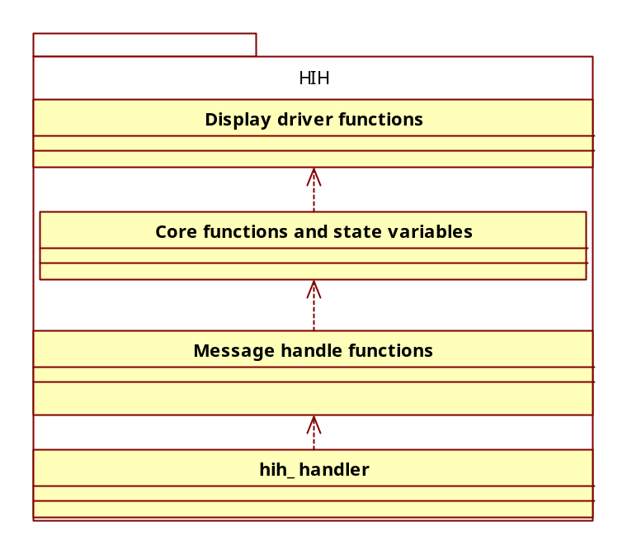
The original UI can be divided to four layer:
hih_handler
This is the HIH main task handle function which listens and dispatches message to specific message handle function.
Message handle functions
These functions handle one type of message, and call core functions to deal with the business operation.
Core functions
Implements the HIH business logic and controls the state of HIH.
Display driver functions
These functions send display instructions to display handler to render screen in display device.
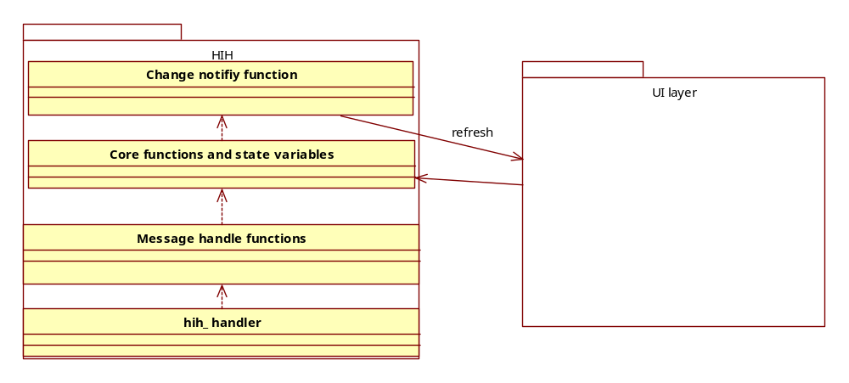
After improvement the display driver functions are moved to UI layer, when the state of HIH changed, the ‘change notify function’ tell the UI layer the state has changed, the UI layer then in charge of rendering proper screen and show to user.
On the other way, the user input on UI layer would transfer to function call on HIH core functions to perform the actual operation.

State management
The code that change the HIH state is spread around every where, it’s hard to read and maintain.

The user menu configuration files
Current system uses a lot of files to configure the user menu, most of these file are in binary file with its own local format, although some tools are provide to modify these files, but XML format may be better for its readability and universality. Because some files are related to BOS, The new configuration files should accord with the BOS specification.

Product Menu file
“*.MN”, define the product menu; also define options of a product.

Dosage file
“*.REC”, define dosage options of a product.

BOS JUG file
“*.KAN”, define jug options of a product.

Icons file
“*.BMP”

The improvement steps

Appendix

